Cryptocurrency Market Data Analysis

Bitcoin (Cryptocurrency and worldwide payment system)

Bitcoin do not have centralize controlling authority and it was introduced by Satoshi Nakamoto in years 2009.

Bitcoin trade happens between peers based on mutual trust which at first looks very suspicious and dangerous but due to use of Blockchain technology it is almost impossible to get hacked or cheated by malicious users. Bitcoin holders are using this virtual currency for trading things freely without any meddling of authority and without any fear of getting your account freeze due to some reason.

Above all Bitcoin claims to have solved below issues which are very often seen in traditional banking system

1) Fake Currency

2) Long Banking Time

3) Bank Collapse

4) Financial Crisis(2008 financial crisis)

We do have PayPal , Paytm , Citrus but again they are dependent on banks

Some more benefits

1) No transaction fees is required - All transactions are completed within minute

2)It is decentralized in that no one person own blockchain network

3) It can never be manipulated or hacked because of the basic structure of Blockchain

### About the Dataset:

Dataset was downloaded from <https://www.kaggle.com/jessevent/all-crypto-currencies/home> , which included historical price information of some of the top crypto currencies by market capitalization , the following fields are as follows:-

Date : date of observation

Open : Opening price on the given day

High : Highest price on the given day

Low : Lowest price on the given day

Close : Closing price on the given day

Volume : Volume of transactions on the given day

Market Cap : Market capitalization in USD

Close ratio: It is the daily close rate, min-maxed with the high and low values for the day.

Close Ratio = (Close-Low)/(High-Low)

Spread: It is the $USD difference between the high and low values for the day.

Slug : Info about type of currencies, which are as follows:-

1. Bitcoin
2. Ethereum
3. Ripple
4. Bitcoin cash
5. Bit connect
6. Dash
7. Ethereum Classic
8. Iota
9. Litecoin
10. Monero , etc.

Info about the data could be given, using the function data.head(10)

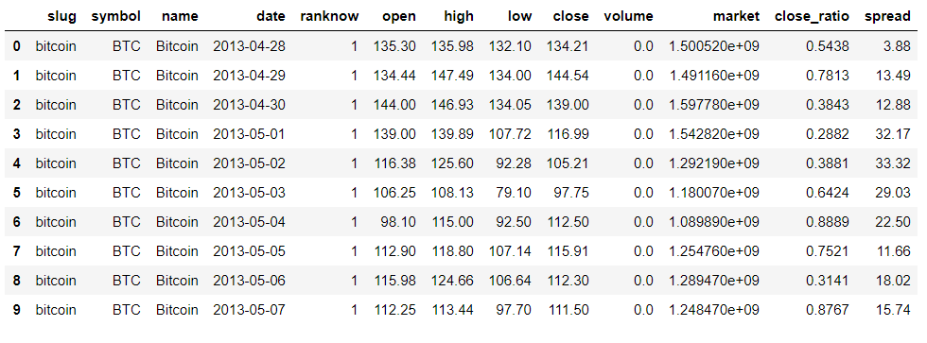

In order to get more information regarding the data types in the dataset, we use the following command:

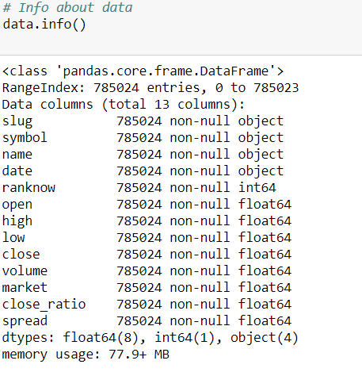

### Context of Study:

Things like Block chain, Bitcoin, Bitcoin cash, Ethereum, Ripple etc. are constantly coming in the news articles that we read. So we wanted to understand more about it which made us to get started with this analysis. Once the basics are done, the questions we felt which needs to be answerable were:-

1. How many cryptocurrencies are there and what are their prices and valuations?
2. Why is there a sudden surge in the interest in recent days?

For getting answers to all these questions (and if possible to predict the future prices ;)), we started collecting data from <https://coinmarketcap.com/> about the cryptocurrencies.

So what’s next? Now that we have the price data, it was needed to dig a little more about the factors affecting the price of coins. Then we started of with Bitcoin and there are quite a few parameters which affect the price of Bitcoin. Thanks to <https://www.blockchain.com/explorer> , we were able to get quite a few parameters on once in two day basis.

This will help understand the other factors related to Bitcoin price and also help one make future predictions in a better way than just using the historical price.

### Inferences needed to be drawn from the data set:

Some of the questions which could be inferred from this dataset are:

1. How did the historical prices / market capitalizations of various currencies change over time?
2. Predicting the future price of the currencies

### Data Preprocessing :

Steps involved in data preprocessing included:

1. Converting the data type of time series variable called Date (Object to Datetime):-

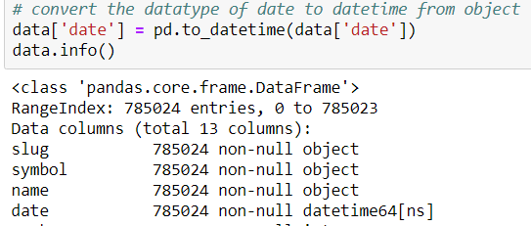

1. Normalizing data points such as volume of the data and market cap value to its nearest approximates.

### Bitcoin Trend Analysis:

### Agenda:

. Most trending cryptocurrency named as Bitcoin needs to be analyzed .

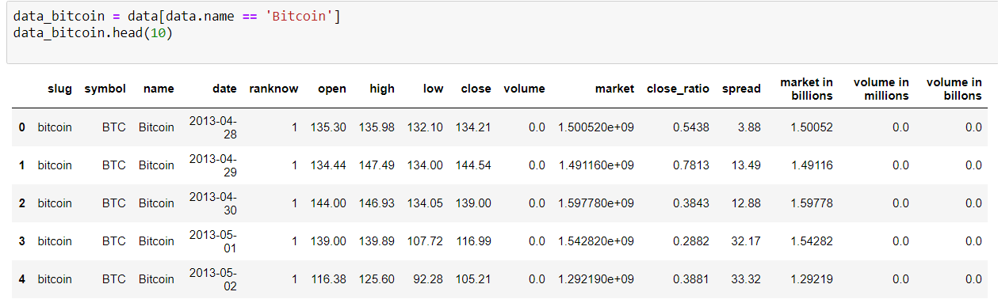

. To make use of the trend plot tsplot() in order to plot a time series plot.

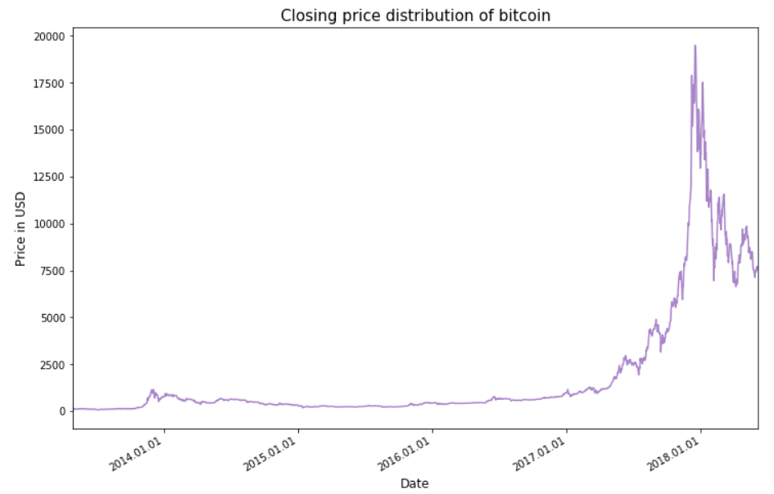

From the above plot we could easily see that there a sudden increase in Bitcoin value during the early 2018, because of the large institutional investors, who hedged those funds. As a result big investors were waiting for the right time to step in.

Ranking the Top 10 crypto currencies based on different parameters:

Categorization based on Market Capital values:

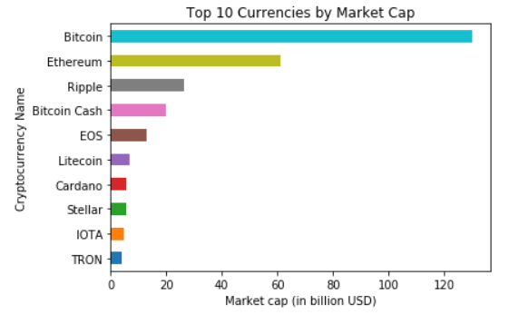

. From the above bar plot we could say that Bitcoin has the topmost market and Ethereum as the second highest within this following years of analysis

Categorization based on Transaction Volumes:

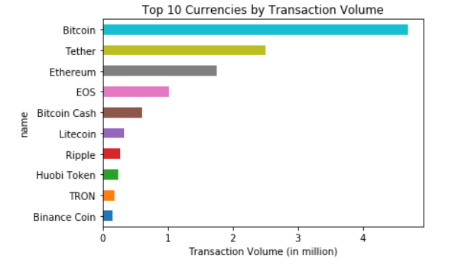

Based on transaction volumes consumed Tether has more transactions than Ethereum.

### Trend Analysis based on the currency closing values :

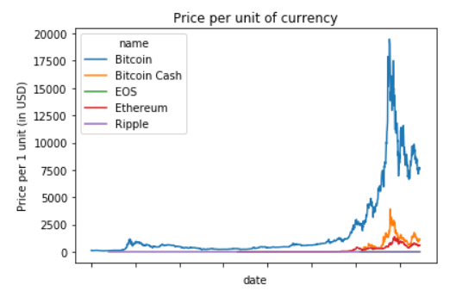

In could be seen that there is a steep increase in the bitcoin currency value over a span of time, reason for it might be due to investor confidence on it. In other words, the price is determined only by what the market is willing to pay. If more people want to buy bitcoins, then the price will increase. If more people want to sell, the price will decrease.

### Data Modelling:

We are going to use one of the finest forecasting algorithms known as prophet. Prophet is a procedure for forecasting time series data based on an additive model where non-linear trends are fit with yearly, weekly, and daily seasonality, plus holiday effects. It works best with time series that have strong seasonal effects and several seasons of historical data.

Prophet Model:

When applied to data frame data_bitcoin_analysis, in order to forecast price of bitcoin 90 days in future using the fit and predict function as follows:

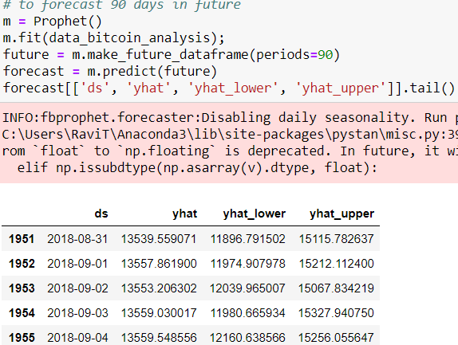

From the above matrix we could say that the bitcoin value was predicted 90 days ahead from last data point available in the dataset.

Terms used in forecast matrix:

ds -> denotes the future dates

yhat -> predicted value of bitcoin price on that specific day

yhat_lower, yhat_upper -> confidence intervals

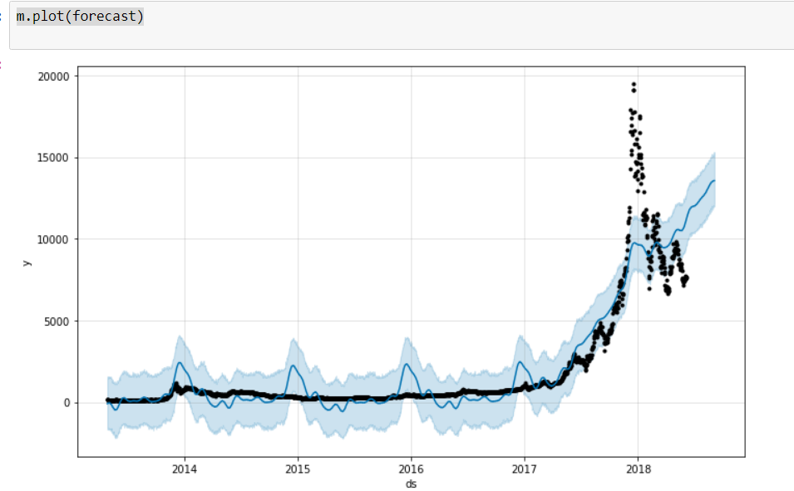

The above plot speaks about the forecasted value of bitcoin until the period it was requested. We could see from the plot that there was a sudden increase in its value since mid of 2017, i.e. ( ever since investors started believing this payment mode).

We can break down the analysis on raw data to its sub components of time series using the components() in prophet, this is as follows:



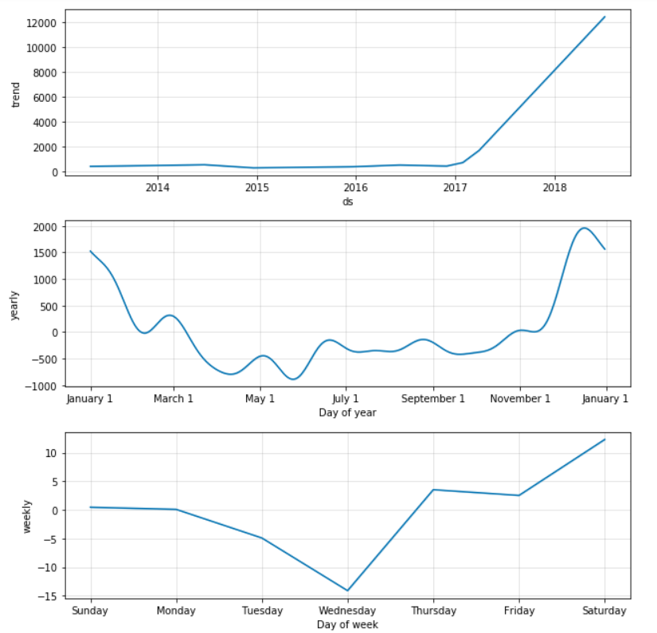

### Conclusion:

Looking at the weekly trend, there does not appear to be any meaningful signal This is to be expected as the random walk theory in economics states there is no predictable pattern in stock prices on a daily basis. As evidenced by our analysis, in the long run, bitcoin price tend to increase, but on a day-to-day scale, there is almost no pattern that we can take advantage of even with the best models.

In reality, when the market drops, don’t withdraw because it will go back up according to history. On the overall scale, the day-to-day fluctuations are too small to even be seen and if we are thinking like data scientists, we realize that playing daily stocks is foolish compared to investing in the entire market and holding for long periods of time.

### References:

Koehrsen, W. (2018, January 08). A Theory of Prediction – Towards Data Science. Retrieved from <https://towardsdatascience.com/a-theory-of-prediction-10cb335cc3f2>

Koehrsen, W. (2018, January 13). Time Series Analysis in Python: An Introduction – Towards Data Science. Retrieved from <https://towardsdatascience.com/time-series-analysis-in-python-an-introduction-70d5a5b1d52a>